Dear Ministry Partners;

"You cannot do a kindness too soon, for you never know how soon it will be too late."
Ralph Waldo Emerson

These past 7 years, I often reflect and think about the many ways kindness has been extended to me by so many people. And not just to me but to this wonderful place we call Grace Mission. Kindness and hospitality has been a hallmark of this incredible place and I have been blessed to have received and witnessed such kindness, generosity, love and hospitality from so many wonderful volunteers, staff, board members and Grace Mission parishioners.

We are reminded in the book of Titus,

"To be gentle, and to show perfect courtesy toward all people" (Titus 3:2}.

Acts of courtesy are extremely meaningful and not in the least bit hypocritical. Words of "thank you" and "yes, please," letters of appreciation and RSVP responses are all services of courtesy. The purpose is always the same: to acknowledge others and affirm their worth.

As I celebrate my 7 year anniversary at Grace Mission I want to acknowledge, affirm and say Thank you to all the wonderful people who have taught me so many things through their acts of kindness, hospitality, generosity and love. Your acts of courtesy haven't gone unnoticed and I am humbled and blessed by your generous hearts and I am truly grateful!

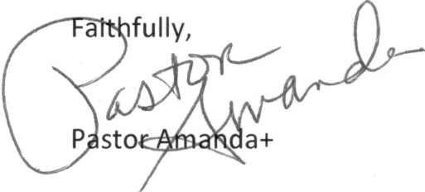
Thank you!

