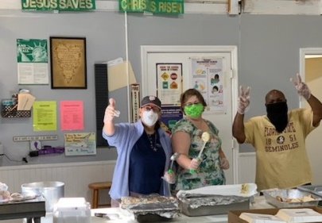
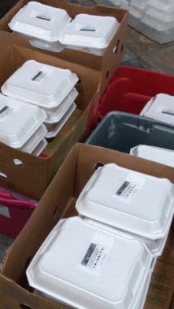
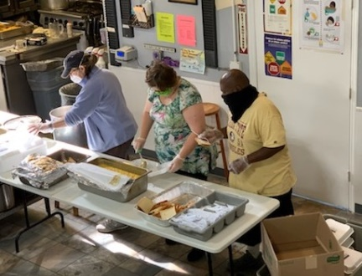
April 17, 2020
Dear Ministry Partners;
There seems to be an endless stream of environmentally negative occurrences with past and recent hurricanes, tornados, earth quakes, flooding and of course the recent pandemic. We have all seen the images of shattered lives. Despite heartache and hardship, we have seen constant and countless ways of people helping people. We all have a natural desire to help and to care, and we simply need to allow ourselves to give from our love doing what we can to alleviate someone else’s burdens. This is all that God asks of us. God reminds us to love Him and love our neighbor as ourselves.
All of us experience fear, but when we confront and acknowledge it, we are able to turn it into courage. Being courageous doesn’t mean never being scared; it means acting as you know you must even though you are undeniably afraid. We have seen this image repeated over and over with the first responders during this pandemic. Their unfailing courage despite the real fear of this contagious virus and the real possibility of being infected themselves or worse, infecting their families. But through their courage we see the glimmers of hope and love in action. It is the kind of love the Bible speaks about – Agape love.
Agape love is selfless, sacrificial and unconditional. Love in action with expecting nothing in return. And this love – agape love – can be contagious and teach us a whole lot about living. Life is too short for us to waste it on fear but agape love gives us the courage to take action when needed. We have seen creative ways this action has materialized in our community. Remarkable and unexpected ways people within our community are stepping out in faith and sharing agape love with their family, friends and complete strangers.
At Grace Mission we have stepped out in faith and have partnered with the Kearney Center (the local homeless shelter) to share agape love during this uncertain and critical time with the most vulnerable people who are experiencing homelessness and poverty in Tallahassee. Hunger is a hard reality for many people and the need is great within our city. Many are struggling. But through agape love, together we can make a difference.
Join us at Grace Mission and the Kearney Center by donating food, supplies, or monetary support. Resources are running low as we continue to step out in faith to deliver thousands of meal each week to our neighbors in need.
We are all afraid but if we can be courageous despite our fears and put love into action many lives can be helped and possibly saved.

In His Love,
Pastor Amanda+

